**Final Project**



Max Sazhaev, Manpreet Matharu, Kyle Puno, Igor Brovchenko

**Table of Contents:**

Page 1: Title and logo

Page 2: Table of Contents

Page 3: Version history, Detailed Game Description, Controls, and Interface Sketch

Page 4: Screen Descriptions (Start State and Gameplay State)

Page 5: Screen Descriptions (Game-End State), Characters/Vehicles, Enemies, Scoring, and Sound Index

Page 6: Art / Multimedia Index (bullet image, grass image, tank mesh, bomb mesh, wrench mesh)

Page 7: All Assets Used

**Version History:**

Version 1 – January 3rd 2018

1. Added first person character, 3 levels with unrelated end conditions, and 2 death walls, start scene, end scene, death scene.
2. Added zombies that chase.
3. Added score, life and time to UI
4. Added gas cans you can collect and simple game music

Version 2 – January 10th 2018

1. Added options, instructions, player health decreasing, human conversion with human models
2. Humans repel, changed end condition to number of converts
3. Added animations, fixed humans and zombies falling over, added nav meshes to levels
4. Changed canvas to include humans left.
5. Added player model and animations for everyone.
6. Made death scene respawn at current level.
7. Control converted zombies
8. Show final score in the end, added sound effects for conversion and death
9. Changed game music
10. Added difficulty that unlocks.

**Detailed Game Description:**

Level 1 – Get to the end of the training maze while picking up gas cans.

Level 2 - Get across the bridge of lava and convert all the humans to zombies.

Level 3 – Convert people in the small town in the middle of nowhere.

**Controls:**

WASD – Forward, left, back, right.

Space – Jump.

Shift – Sprint.

Left mouse button – Select zombie.

Right mouse button – Command zombie

**Interface Sketch:**

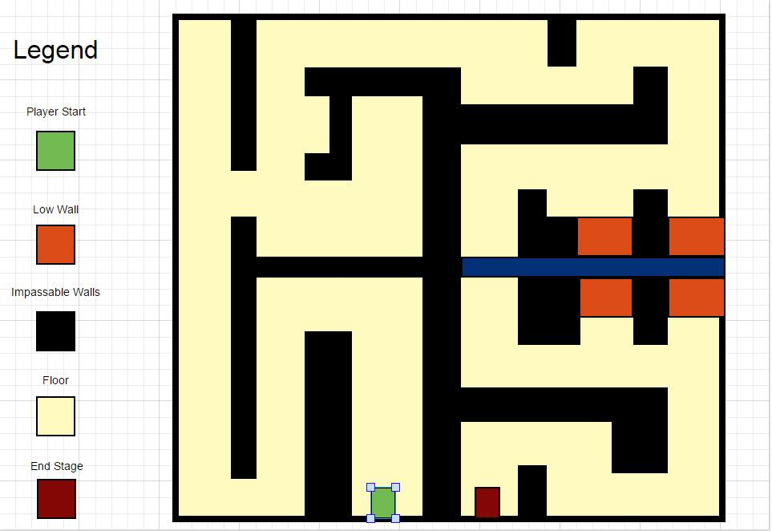

**Screen Descriptions:**

Start State:

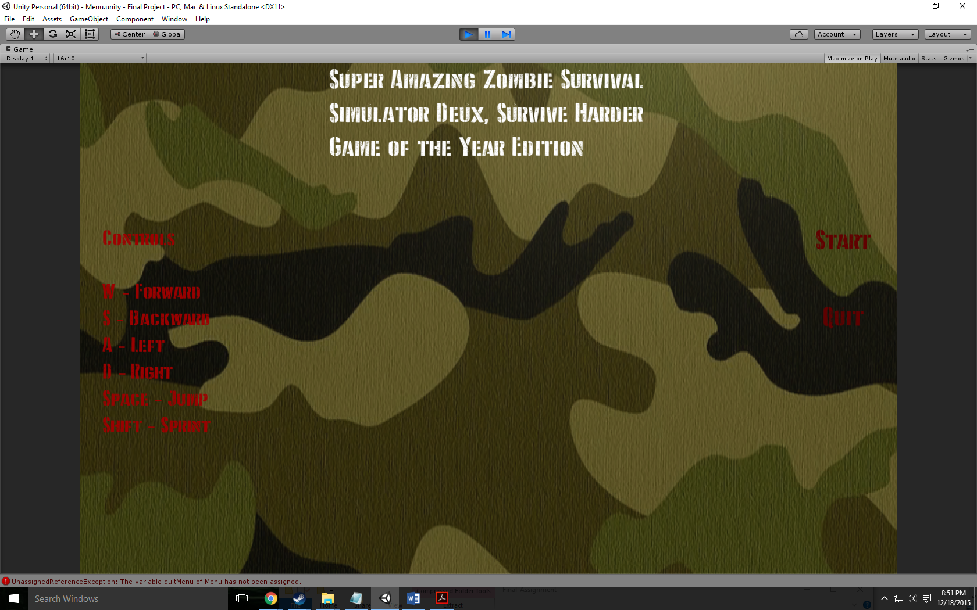

Death State:

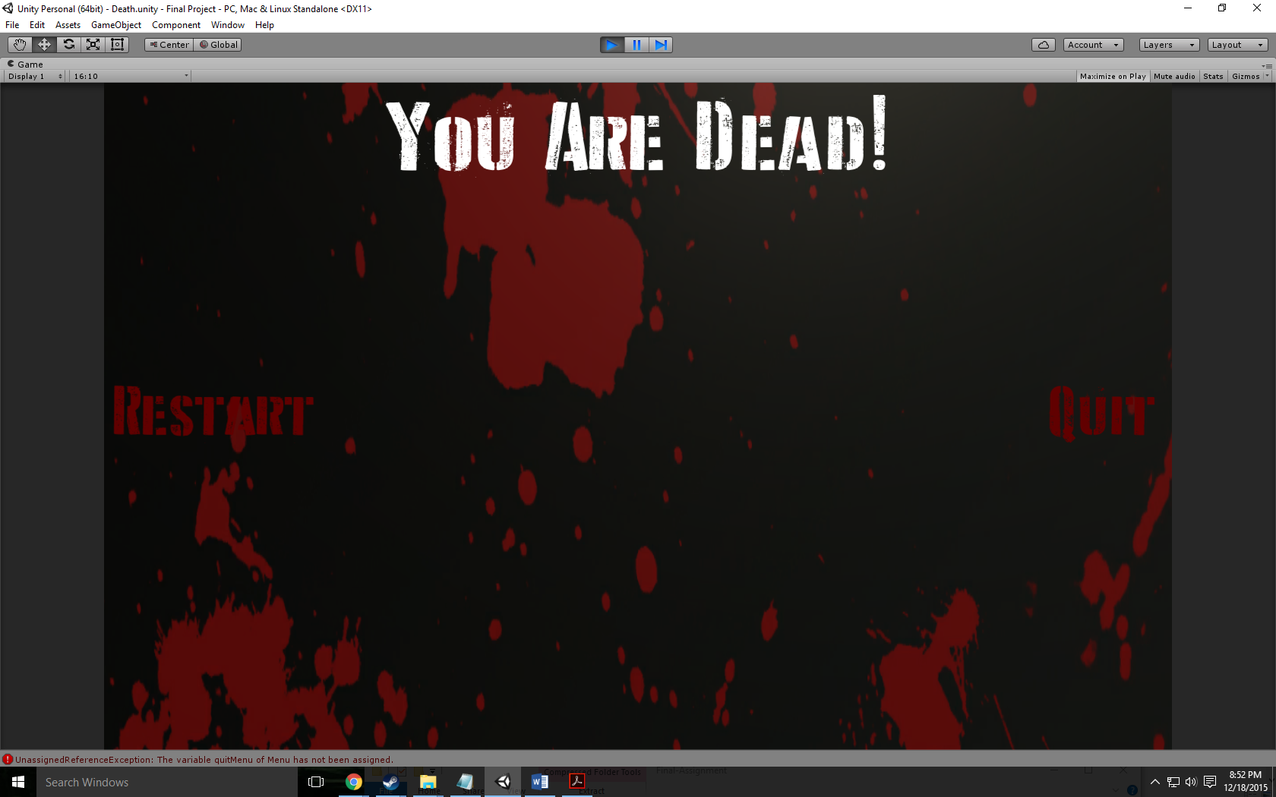

End State:

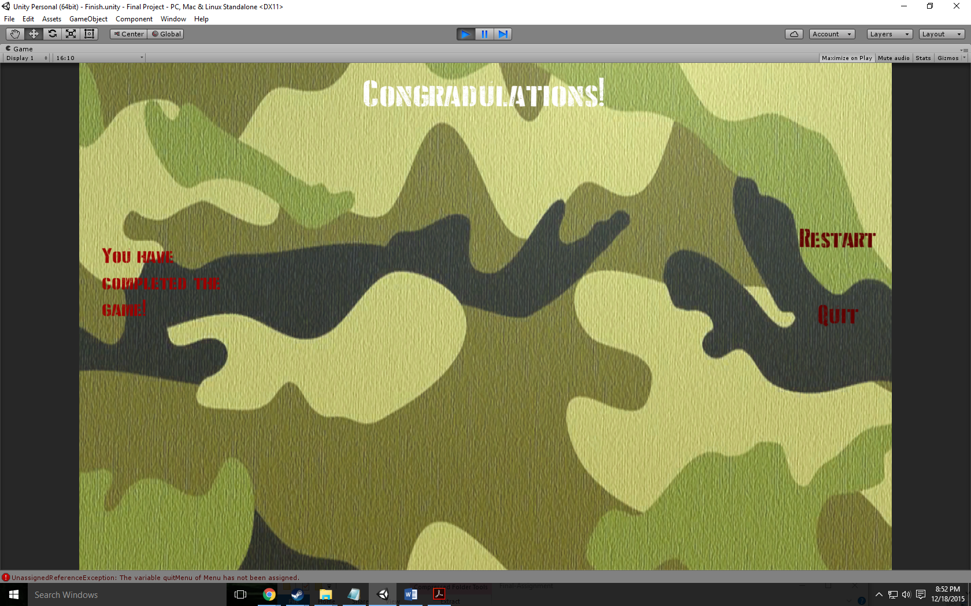

Level 1:

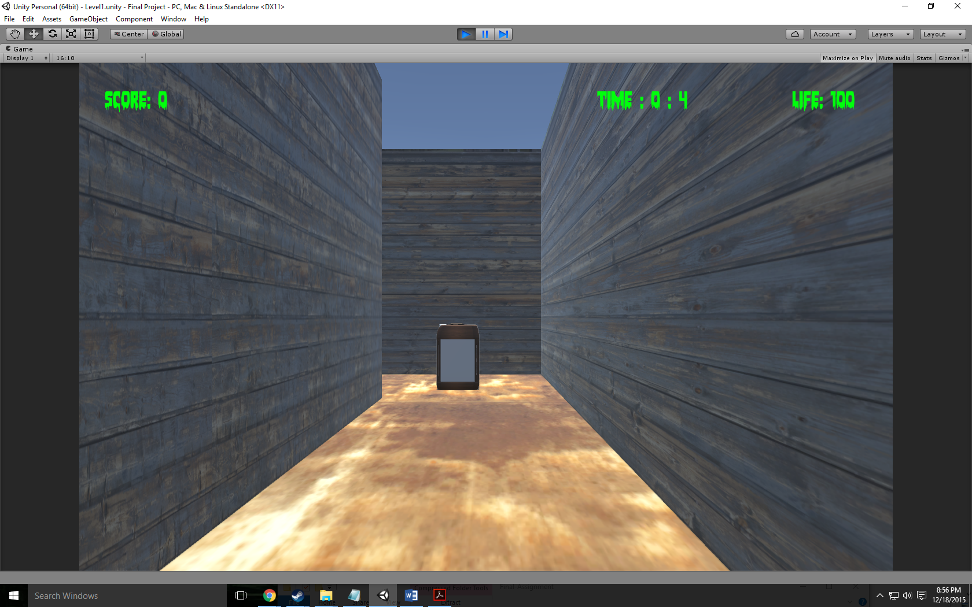

Level 2:

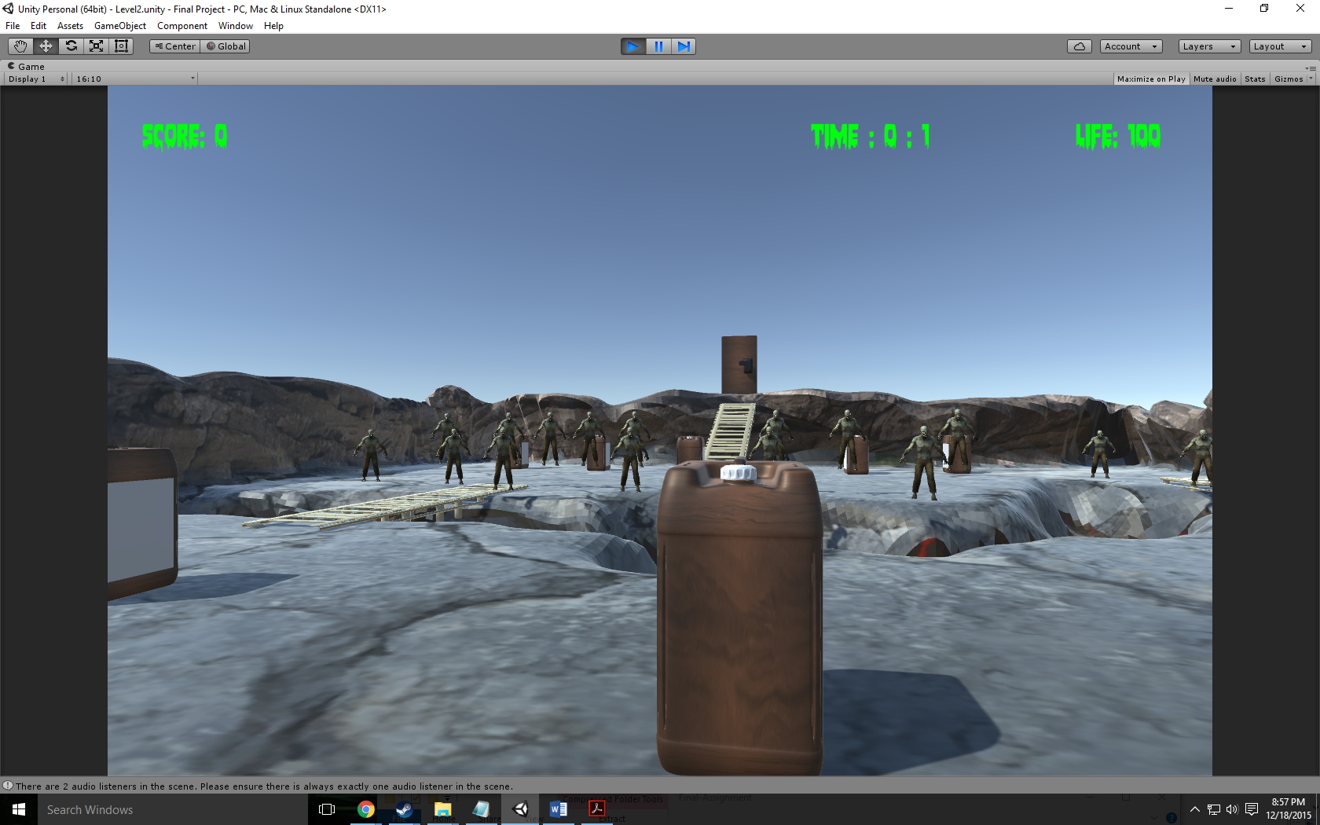

Level 3:

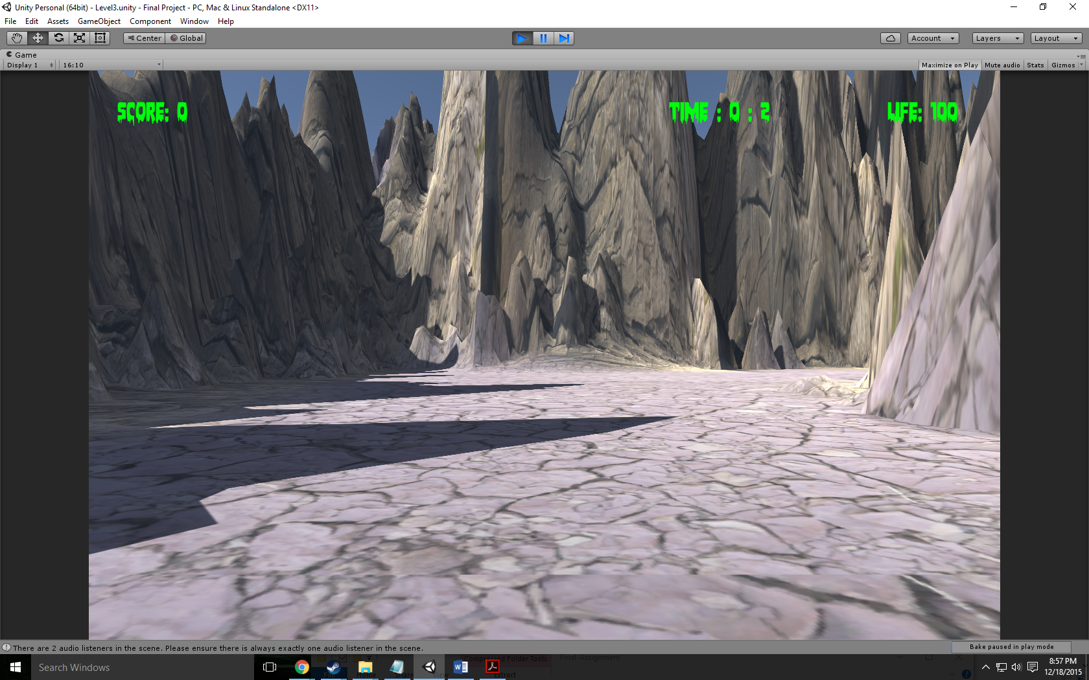

**Game World:**

Happy at first but then turns very dark and epic

**Levels:**

First level: Very happy training session

Second level: Gruesome being chased by zombies

Third level: Epic trying to get to the end destination (car) while being chased by zombies

**Characters / Vehicles:**

Player – moves forward, back, left, and right. Also jumps and sprints

**Enemies:**

Zombie follows with a simple script.

**Scoring:**

100 points per collected gas can on level 1 and 2

99999 points for single hidden collected gas can on level 3

**Sound Index:**

Footstep01 – Walking Sound

Jump – jump up sound

Land – Landing sound

Funeral Music – Death Scene

Life is strange main menu music – Menu Scene

Push it to the limit – First level

Master of puppets instrumental by Metallica – Second level

The Grand Cathedral from Serious Sam the 2nd Encounter – Third level

**Art / Multimedia Index:**

Rust Texture:



Water Texture:



Wood Texture:



Main menu background:

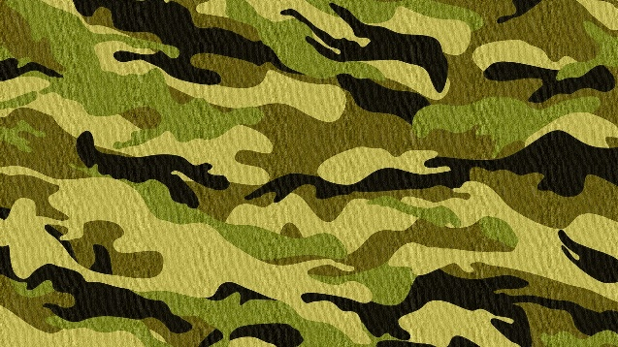

Death scene background:

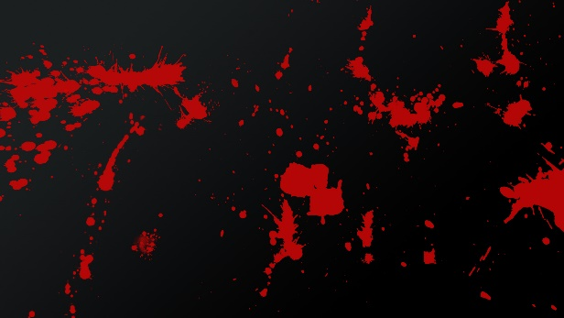

Car:

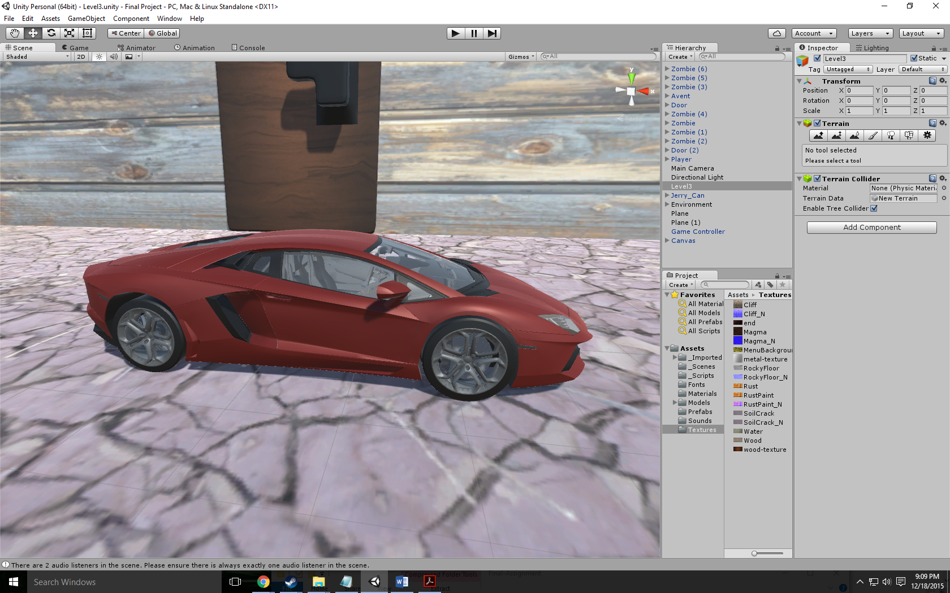

Door:

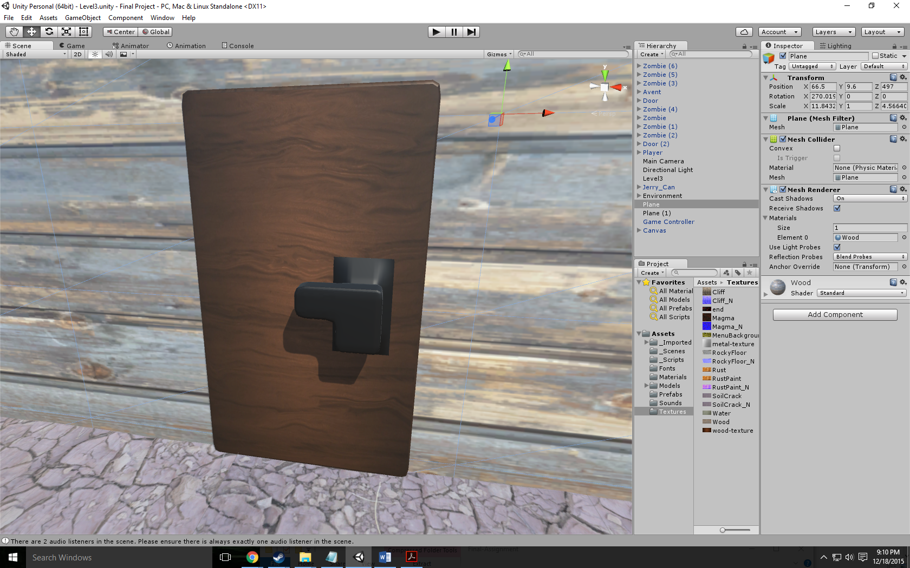

Gas Can:

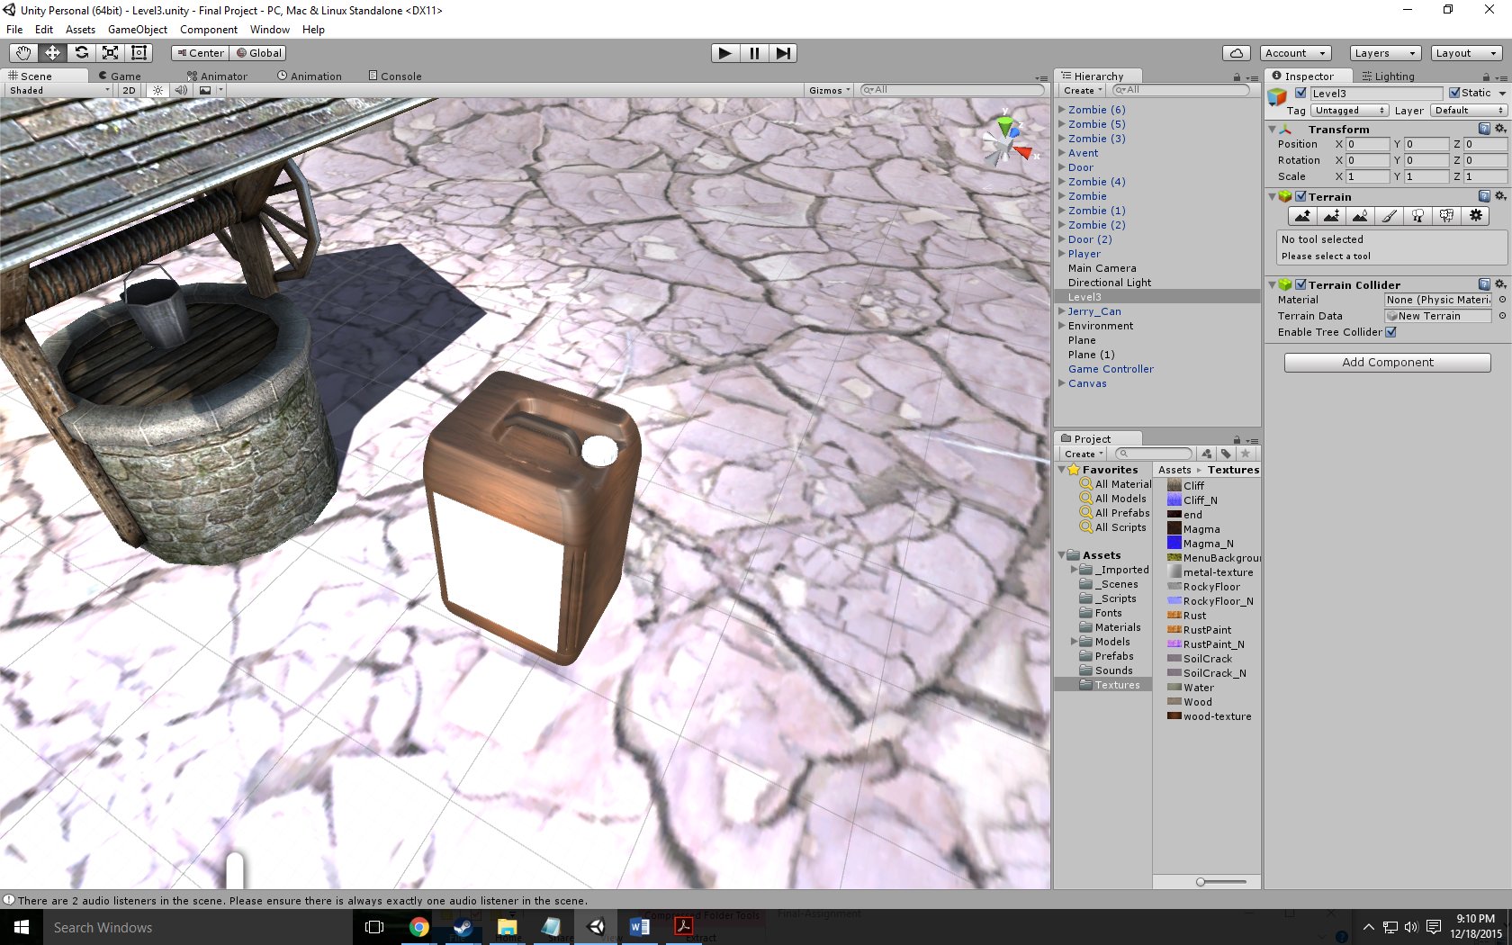

DDay font:

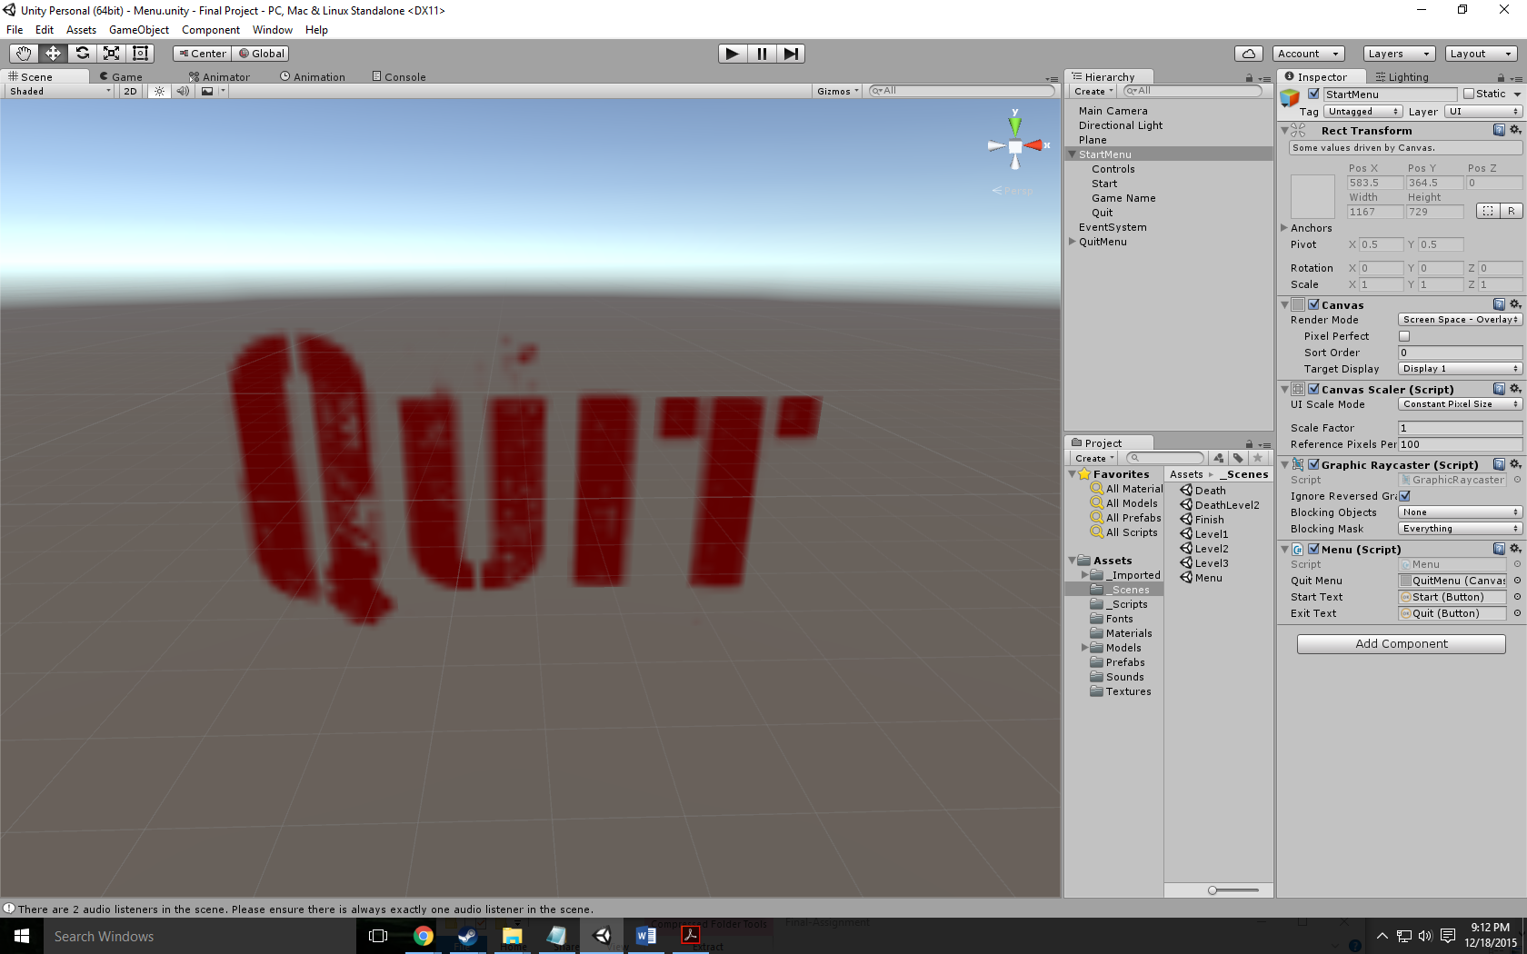

Bloodlust font:

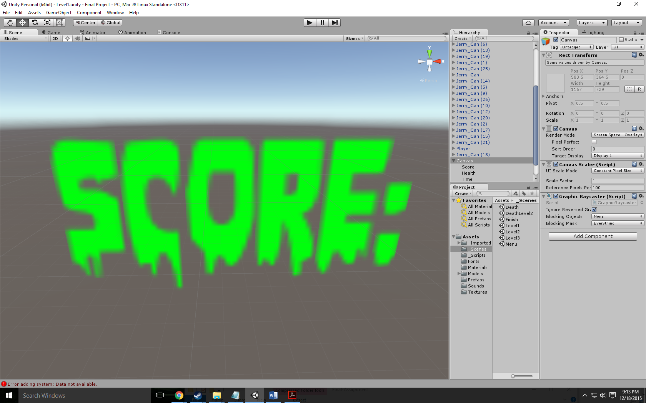

**All Assets Used:**

Wood Floors - <http://www.textures.com/download/woodplankspainted0191/66695>

Rusted Walls - <http://www.textures.com/download/rustpaint0170/31195>

Water Pit - <http://www.textures.com/download/waterplain0035/103458>

Door - <http://tf3dm.com/3d-model/modern-door-60753.html>

Menu Background - <http://wallpapercave.com/wp/9uIjAfm.jpg>

Death Background - <http://orig12.deviantart.net/db12/f/2012/038/5/0/blood_splatter_background_by_pudgey77-d4ozy89.jpg>

Level 1 Music - <https://www.youtube.com/watch?v=9D-QD_HIfjA>

Level 2 Music - <https://www.youtube.com/watch?v=_jYlloUKFmg>

Level 3 Music - <https://www.youtube.com/watch?v=0IVRoqDWwIk>

Menu Music - <https://www.youtube.com/watch?v=S3W0M8SVmk0>

Victory Music - <https://www.youtube.com/watch?v=5ppGs_t6014>

Death Music - <https://www.youtube.com/watch?v=SQ1nGH4VBEQ>

Gas Can - <http://tf3dm.com/download-page.php?url=cooking-oil-jerry-can-88575>

Car - <http://tf3dm.com/download-page.php?url=lamborghini-aventador-42591>

Bloodlust font - <http://www.1001freefonts.com/bloodlust.font>

DDay font - http://www.dafont.com/d-day-stencil.font